# Castles, Cookies & Olive Oil

A lot of big things happened this week. I learned how to decorate some fancy Christmas cookies, I went on a tour of an olive tree farm and learned how olive oil is made, and then Scott and I drove over to Lake Garda for the weekend and had an AMAZING time touring two castles and driving up into the Italian Alps.

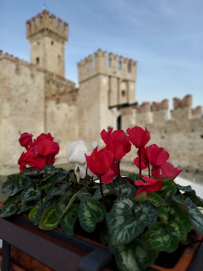

To keep things organized, I'll share my thoughts in order of the weekdays.

Sunday:

Last Sunday evening, Scott and I went for a walk as the sun was setting. We wound our way through the neighborhood behind us and found a new path through a field that was quiet and peaceful.

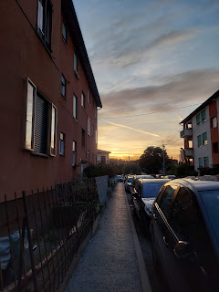

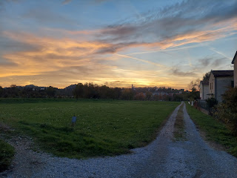

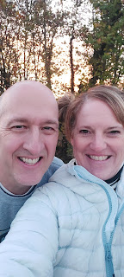

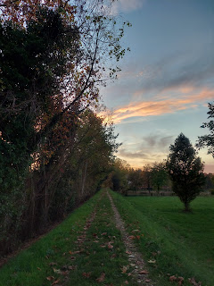

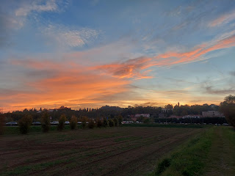

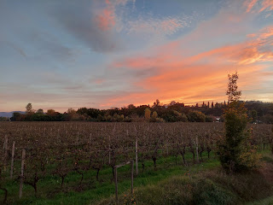

Monday:

I woke up in the wee hours of the morning to use the bathroom and noticed this beautiful moon glowing through my bedroom window. I didn't think taking a picture would do any good, but I was surprised when I checked in the morning and saw that it actually turned out pretty well.

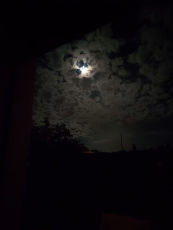

After working on Avery's Quiet Book for most of the day, Scott and I went on an errand and on the way home I convinced him to stop at the Gelateria so I could get some amazing gelato.

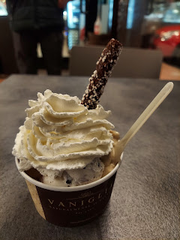

Stracciatella is always a good choice. It's like cookies and cream. You can't go wrong with that.

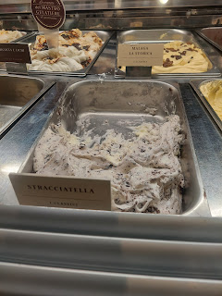

I tried the Nutella kind for the first time and - OH. MY. GOSH. This is now a tie for my favorite flavor of gelato, along with limone.

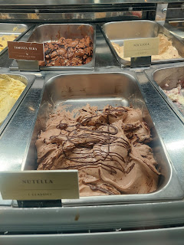

I have only had Sapori di Sicilia one other time, but WOW. It's amazing! It has little bits of candied lemons (or maybe oranges) in the ice cream. It's unusual but delicious! I could not find any list of ingredients for it online. You'll just have to take my word for it.

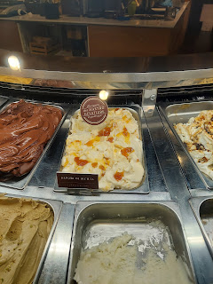

Tuesday:

I pushed through a difficult phase of the quiet book by connecting all the pages together and then mounting them into the inside cover. It took all day, but it was SUCH A RELIEF when I got that part done. That is seriously a tricky phase to navigate through. You have to think several steps ahead of each thing you do so you don't ruin a future step . . .

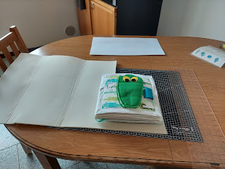

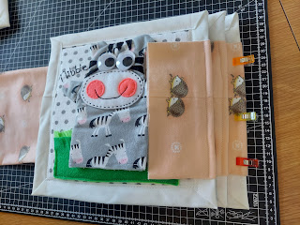

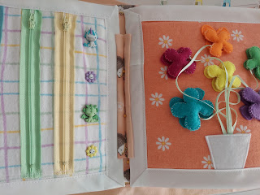

When Scott got off work, he met me on the base so we could get the car cleaned out together. There is an Auto Skills Center where you can get the oil changed, new tires put on, etc. And there is also a car wash and a vacuum you can use (tokens have to be purchased first).

This is one of those interesting Italian car wash setups where you park the car, and you can even get out and stand nearby, while the contraption does all the work for you.

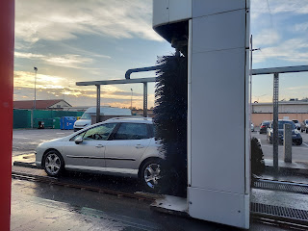

Video of the car while it's getting washed: (32 seconds)

(Sorry - there's not a lot of action until like the last 5 seconds or so)

https://photos.app.goo.gl/RTX4LupePZHY4RP78

Before the sun went down, we washed and cleaned out the car, and took several pictures to help us list the car for sale.

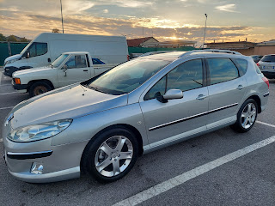

Scott has already had a few inquiries about the car, some of which involve meeting with a couple of potential buyers this coming week. Crossing fingers that we can get it sold . . .

While we were getting the car washed in Italy, we got this photo from Scott's parents back in Idaho. Winter had officially arrived!!

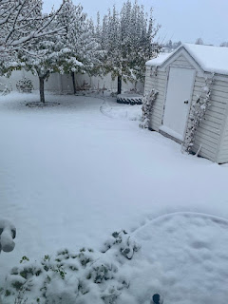

I asked our neighbor, Kim Parkinson, to send me a picture of what it looked like there, too. She sent me this photo looking from their front porch across the street to our house.

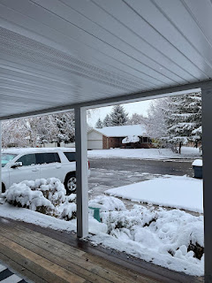

Tuesday evening, I drove about 20 minutes to get to Dedra Tolman's house where we would be learning how to do some intricate cookie decorating. Our church is so amazing! The Relief Society organization is a group of women (18+) who not only meet together 2x/month at church to learn and discuss a variety of religious topics, but is also designed to teach homemaking skills, life skills, and have opportunities to serve within the community. It is a WORLDWIDE society of amazing women who have so many talents to share. Within the Church of Jesus Christ of Latter-day Saints, and wherever you go in the world, you will find a group of women having meaningful and fun activities regularly that you can participate in. Everyone is welcome. :)

This was one of those activities where we got to learn a skill that none of us knew how to do before coming. Everyone was very excited to learn some cookie decorating techniques as the holidays are just around the corner.

Somebody had taken quite a bit of time to organize each person's "station" ahead of time. We each had a box with everything we needed inside.

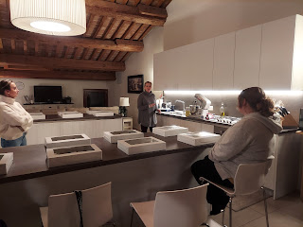

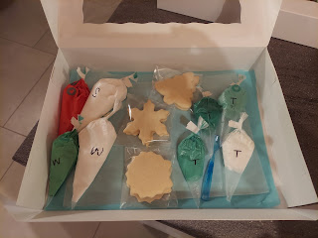

We decorated 2 Christmas tree cookies first (I'll share a better photo in a minute), then 2 snowflake cookies, and then 2 wreaths. We were all intimidated by how fancy the wreaths looked in the example, but they turned out to be the easiest and the most fun!!

FIRST, I need to note that the Royal Icing was prepared ahead of time by Lindsey Zisa, our instructor. She gave us a demonstration on how to make the icing before we began decorating. She uses meringue powder instead of egg whites, because she says it is much more reliable. She likes to use food coloring GEL instead of the liquid, and she likes to incorporate a flavor into the icing (such as almond, or lemon, or mint).

Lindsey showed us how to do the wreaths from start to finish first, emphasizing that with the royal icing, you need to work quickly before it sets. It only took about 1-2  minutes to do each cookie.

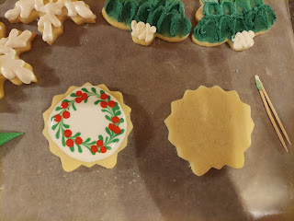

First, you cut the tiniest tip off your piping bag. Less is better. Pipe a skinny line of icing around the cookie to form a circle. She showed us that it's better to lift your piping bag up in the air slightly above the cookie so that you LAY the line of icing down instead of trying to squeeze it directly onto the cookie.

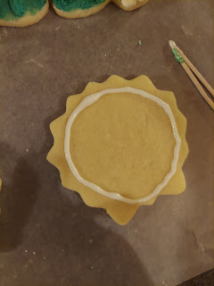

Next, squeeze harder to get some good blobs of icing into the center area. Do not try to fill it all in.

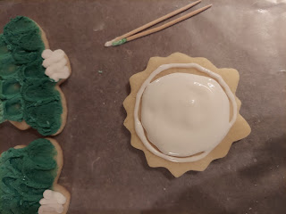

Use a toothpick to gently swirl the blobs in the middle to incorporate them and blend them into the circle that you made around the perimeter. I think the circle acts as a nice barrier to hold everything in the middle.

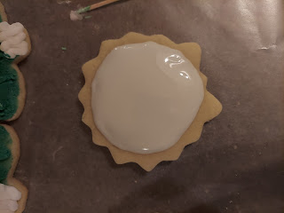

Next, pipe a series of long and short lines of green icing all the way around. They don't need to be perfect or amazing. You'll see why in a minute.

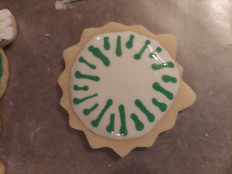

Video of the COOLEST PART: (15 seconds) This is where we used a separate toothpick to turn those lines into beautiful leaves. MAGIC!!

https://photos.app.goo.gl/GdQuXSH3fbe3z24M7

Lastly, pipe some red icing dots on in clusters of 3 for the holly berries. VOILA!!! Ah. Mazing. As I said earlier, that only took about 1.5 minutes from start to finish. Every single one of us felt like a million bucks as we saw what we had accomplished by the end of this.

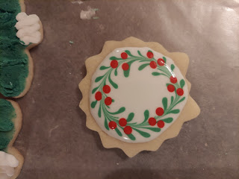

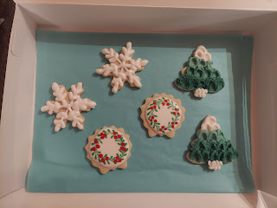

Someone asked Lindsey, our instructor, how she learned how to do all of this. She shared that when her little daughter passed away, she needed something to do with her hands to keep them busy. She tried needlework and crocheting. She tried painting. She tried several things, but nothing worked until she tried cookie decorating. Through trial and error, she really found a talent and a love for something new. And it helped to heal her heart in the process. WOW.

Wednesday:

I met up with 5 other ladies to go on a tour of an olive orchard near Soave, about 40 minutes west of my house. I learned that this group consists of several ladies whose husbands are here in the military and they get together every Wednesday to do a field trip of some sort. I am now part of this group, and I am looking forward to more fun adventures in the months to come!

The name of the olive farm is Frantoio Bonamini. It's been continuously here in this spot since 1965, but was functioning before that in another location. Our tour guide was Rebecca, granddaughter of her two grandparents who built up this farm in Illasi, Italy.

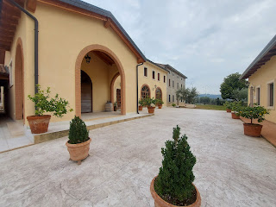

There were 6 in our group along with a couple from Germany who joined us. Behind Rebecca in the photo below (she's wearing all black), are some of the olive trees. On the ground you can see some green matting underneath the trees. They have some motorized tools that "rake" and "comb" the branches of the trees to shake all the olives off. The ground netting can then be gathered up to dump all the olives into large crates.

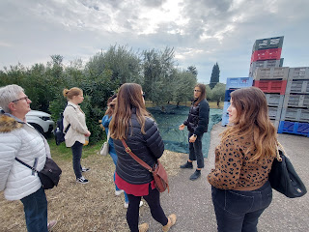

Rebecca told us that they have to work quickly to harvest the olives in order to ensure the freshest quality of olive oil. Once the olives are shaken from the tree, the staff only has about 12 hours to make them into olive oil.

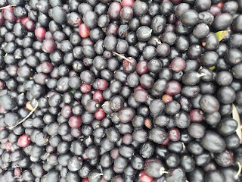

These are some of the crates full of olives. While many of them belong to the Bonomini farm, local farmers can also bring in their own personal crops to convert them into olive oil as well. If the crop is large enough, they can use the Bonamini equipment to press and make oil for themselves. If the crop is small, they can just donate their olives to the Bonamini business and trade for bottles or containers of already-made oil.

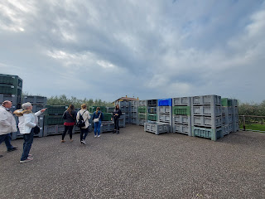

Forklift drivers dump one crate at a time into the sorter. This step sorts out the olives from the leaves and stems.

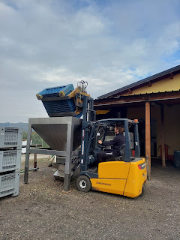

Video of the olives getting dumped in: (14 seconds)

https://photos.app.goo.gl/otL4sUZBEV8nsMHz5

Video of the sorting machine: (34 seconds) *Note: the leaves and stems are used for compost once separated out from the olives.

https://photos.app.goo.gl/k3m2wQYkVmcFbQxP6

Next, the olives need to get washed. They have been sitting on the tree for months, getting coated with rain and dust.

Video of the olives going through the "washer": (24 seconds)

https://photos.app.goo.gl/oje8raiXpXBkVqTc6

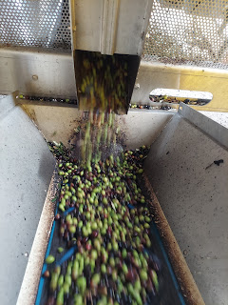

Once they've been cleaned, they can go to the pulverizing machine. Here, they get mashed into a beautiful (and thick) purple soup.

Video of the mashing process: (17 seconds)

https://photos.app.goo.gl/LvrF3wEaRK7pqsyf9

Each of the 5 compartments on the "masher" has its own time control (as seen below), and each is climate controlled. It takes about an hour to fully mash everything into a nice consistency.

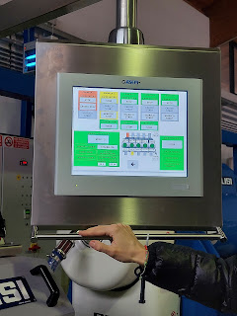

From the masher (on the left) it heads over to another separator. In this step, the pits and the pulp are separated from the liquids using centrifugal force.

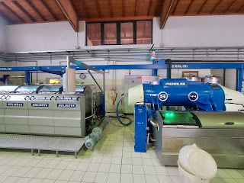

Rebecca told us that they usually use the discarded olive pits for additional compost material. But this winter, fuel costs (to heat the home) have gone up in price by 4x here in Europe. She said that buying pellets for a pellet stove used to cost about $4/unit. They now have to pay $15 for the same size of unit. (I don't know how much each unit is) They tried a recent experiment by using the olive pits instead of pellets in their stoves AND IT WORKS!! It works so well that other families in the area have asked if they can purchase olive pits to heat their homes instead of having to buy the expensive pellets. WOW.

This is what it looks like when the liquid is separated from the pits and the pulp. It still needs one more run through another centrifugal force process to separate the water from the oil though.

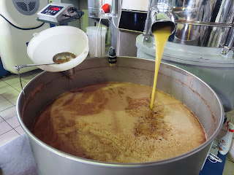

Once that has been completed, and the olive oil has been isolated, they fill up these giant tanks for further refinements. The more refining the oil goes through, the more "extra virgin" it becomes.

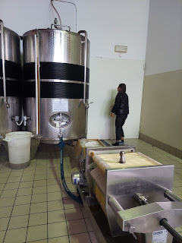

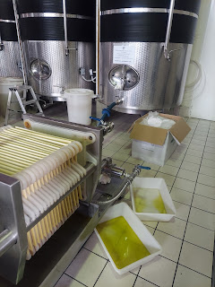

They do sell an unfiltered olive oil in their shop. Italians really like unfiltered olive oil. It's stronger and more flavorful. The color of unfiltered oil is more cloudy, which some people are fussy about. (I bet it's just mostly the judges that get fussy - in a competition, ha ha.)

We were then led into an adjacent warehouse where several tanks are kept temperature controlled until an order needs to be filled. They sell their olive oil all over the world, not only to individual consumers, but to restaurants and other organizations as well.

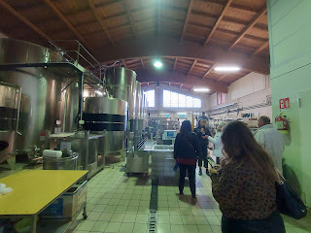

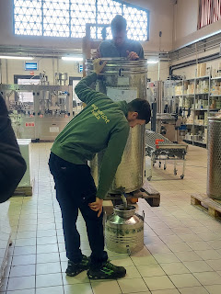

Rebecca told us that by law they have to put an expiration date on the label when they fill a bottle. But unless the olive oil has been left sitting in extreme heat for long periods of time, or if the bottle didn't have its cap securely on, then it can last indefinitely. But since the law requires an expiration date, they put 18 months as the expectation.

Their olive oil can sit for long periods of time in the tanks and be just fine for when it's time to fill the bottles or containers. How nice.

Next, we were led back over to the shop where we started.

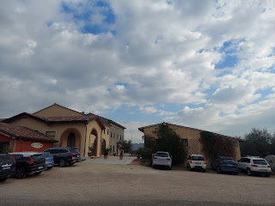

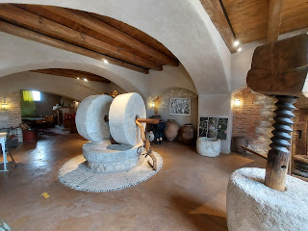

Rebecca pointed to this painting and explained several steps of how olive oil was made anciently.

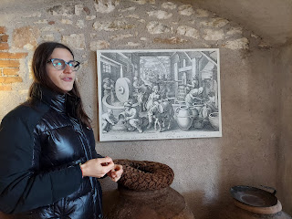

Video of a portion of her explanation: (48 seconds)

https://photos.app.goo.gl/utvZsNBM9KmZqCqw9

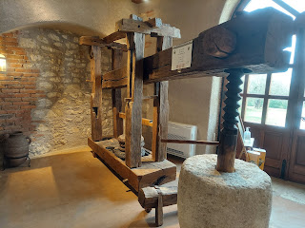

Next, we walked over to the tasting room next door, passing some beautiful baby lemon trees on the way.

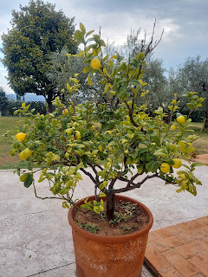

At our table was Andrea (on the left), Catherine (black jacket), Katie (white jacket), and Alison. Marnie was over taking pictures across the room.

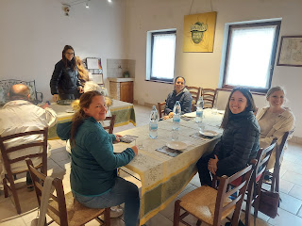

We would be sampling 3 types of olive oil using small cups and pieces of bread. There were also samples of other products they sell in the shop (pesto, tapinade, and something else . . . I can't remember what it's called).

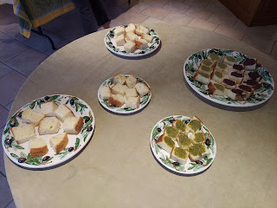

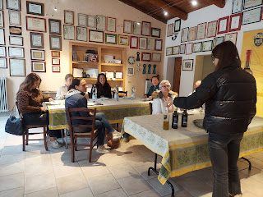

Rebecca taught us to do a sharp intake of breath through our front teeth as we took a sip of each type of olive oil. She said that this helps to distribute the oil throughout the mouth, including the taste buds at the back of the tongue. She first had us hold our little cup with the oil sample by cupping it on the top and bottom with our warm hands. The oil was a little cold as she poured it from the bottle, and needed to be warmed up to release the flavors. You cup the top to protect those flavors from disappearing too quickly before you can taste it.

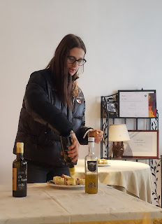

It felt a little like we were having a wine tasting or something, ha ha. I've never actually done any wine tasting since I don't drink alcohol - but the procedure felt snobby and amazing at the same time.

Below: Their

black olive

oil on the left has won some top awards in Italy. The middle oil, a

green olive

based oil, won the GOLD MEDAL at an international competition in NYC!! WOW. And the one on the right is their

unfiltered

olive oil.

I liked the black version better. It was more mild but still flavorful. The green version was spicier - she described it as "peppery". But it can also be more bitter. The unfiltered oil was the most "peppery" and bitter, but also the most flavorful.

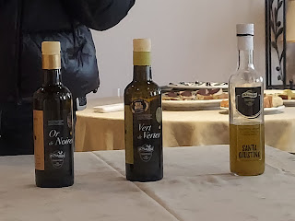

This was a VERY cool visual explanation on how many olives does it take to make this much oil.

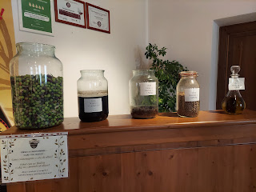

7.5 kilos (16.5 lbs) of olives =

50% water

20% pulp

17% pits

13% oil

After our tasting session was all done, we walked back over to the showroom to do some additional tasting and some shopping.

I sampled some oils that had been infused with extra flavors, such as: garlic, lemon, rosemary, oregano, basil, truffle, pepperoncini, and one other one that I can't remember. I really liked the garlic, lemon, and rosemary. A friend had also told us that the Rose Balsamic Vinegar that they sell here is TO DIE FOR. I tasted a little spoonful and I would have to agree!! Oh. My. Gosh. SO GOOD!!

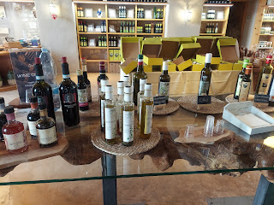

What a delightful day! I learned so much and was so appreciative of the whole educational experience.

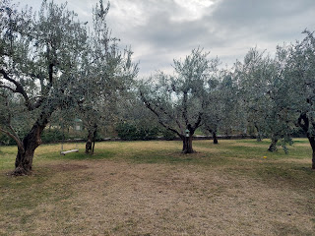

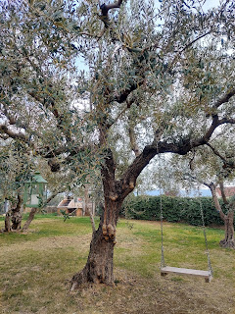

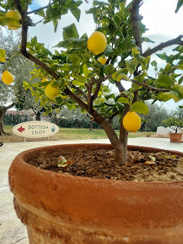

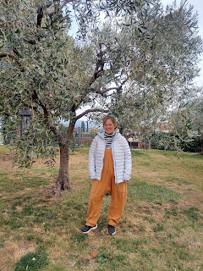

Thursday:

I finally went to get a massage. I haven't had one in almost 3 months now and my forearms were really in a bad spot. I get carpal tunnel issues, mostly in my right forearm, and regular massage has kept it at bay for several years.

I walked about 10 minutes from my house to go to the same place that I went back in May. SpaLab is the name.

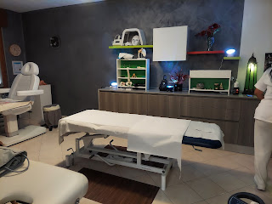

She did a great job. I love how she uses hot rocks as part of the massage. It feels so amazing, especially now that the weather is colder. She noticed that in my right forearm, there is a small lump. She seemed very concerned about it and gave me a lot of counsel on what to do in the next few days. She wants me to see a doctor about it as well . . . it's probably nothing serious, but I'll get it checked soon.

A couple hours later, Scott and I headed west to go on a weekend adventure together. He had a 4 day weekend once again, only this time it was Thurs-Sunday instead of the usual Friday-Monday. We chose to stay at the south end of Lake Garda so that we could explore some beautiful places in that area.

Here is the inside of our AirBnB, which was a studio apartment. It was located near the center of Desenzano del Garda and was within a short walk of the Castle and the waterfront. (only about 5 minutes away)

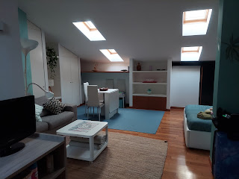

Both Charmaine and Amber called back to back as we were getting settled into our AirBnB. I had a good chat with each of them. Charmaine was driving to work in San Diego, so we didn't do a video call. But Amber and I did. :)

We visited about her painting project for the day, which is her annual tradition to honor the memory of her stillborn son, Jonny. He would have been 6 years old on Thursday.

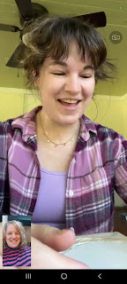

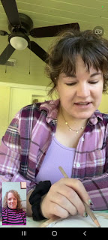

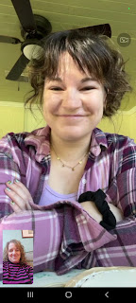

Because I'm on the other side of the world, when I'm usually close to the cemetery where Jonny is buried, I wasn't sure how to spend the day. I decided to keep it simple and just pray to feel close to him. As soon as I ASKED for that in my prayer, he was instantly there and my heart filled to the brim in

one second

with all the love he had to share with me. It was incredible!! It's like he's always right there anyway, whether I'm asking to feel close to him or not. He is a special boy and I'm really looking forward to meeting him in heaven some day.

Once the phone visits were complete, Scott and I went for a walk down to the water's edge. Lake Garda is the largest lake in Italy, and Desenzano is the largest city on the lake (pop. 30,000). But the area where we were was mostly just pedestrian alleyways and cute little shops and restaurants.

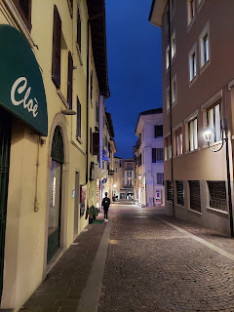

Everything was quiet in the evening and we enjoyed just wandering around for a while.

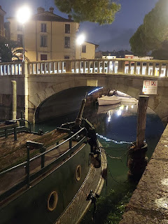

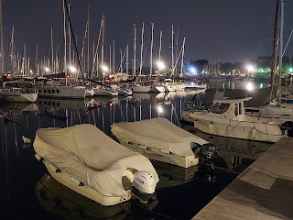

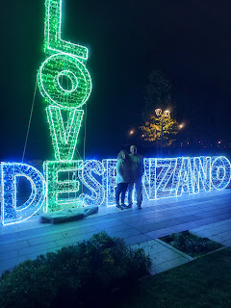

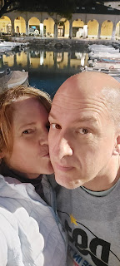

I took a picture of Scott on the bridge as he was also taking a picture of me. :)

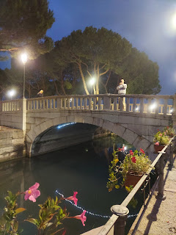

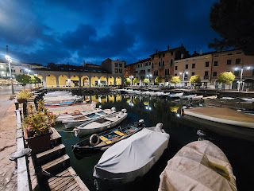

Video of some ducks right next to me, trying to be brave enough to jump down into the water below: (35 seconds)

https://photos.app.goo.gl/uKUbpLuTYDxtbC796

Video of the harbor area: (24 seconds)

https://photos.app.goo.gl/TUWcGnu2NQXuoSPKA

They even had a cute Disney themed carousel ride for the little ones. It was closed that evening, and perhaps even for the season. But I can think of 2 little girls who would LOVE to ride on it . . .

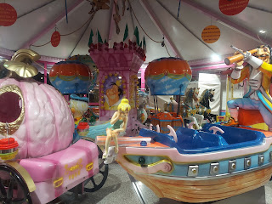

Scott and I always wonder as we see so many Italian clothing shops, how do they make any money? There's usually just a few targeted lines of clothing, with a very specific theme in the window, but usually no customers inside. Maybe one or two sometimes, but they are usually empty. How do they survive??

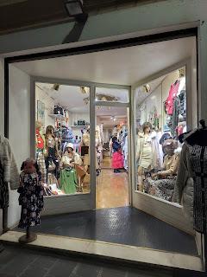

Friday:

After a simple breakfast that we brought with us (granola and shelf-stable almond milk), we prepared to head out on some adventures for the day. And yes, the AirBnB told us ahead of time on the listing that the kitchen "ceiling" was low . . .

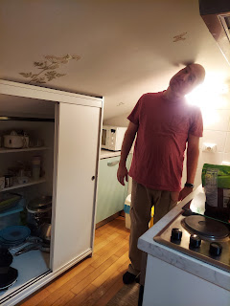

The tunnel below is how we could easily get out to the harbor from our alleyway street.

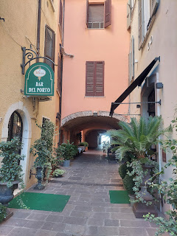

The ferry boats were not running on a Friday - because it's the "low" season. So we changed our plans and decided to go find the castle behind our AirBnB first.

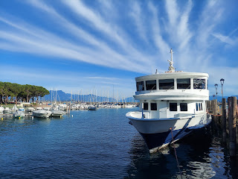

Up the narrow alleyways we went . . .

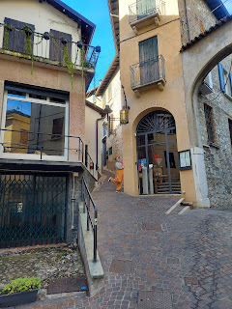

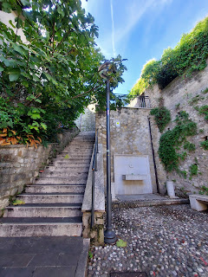

After several series of steps, we made it! This is the Castello di Desenzano del Garda. Built in roughly 1000 AD, it was intended to protect the people from barbarian invasions.

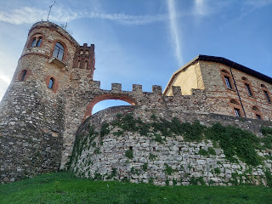

We wandered around outside, since the interior was closed for the day. The views were quite nice.

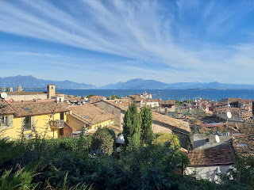

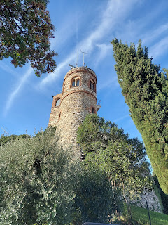

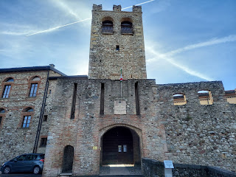

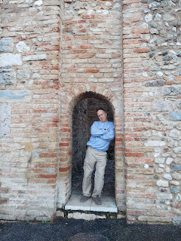

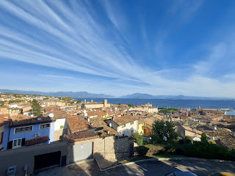

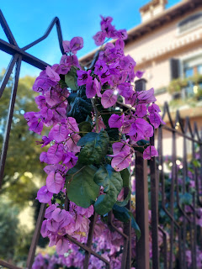

We decided to hop into our car and just drive over to nearby Sirmione, since the ferry wasn't running. (Pronounced: Seer-mee-OHN-ay)

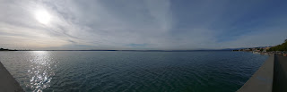

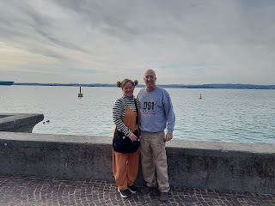

From where we found a parking spot, it was a very short walk to the castle.

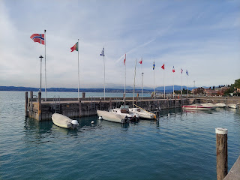

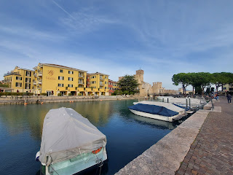

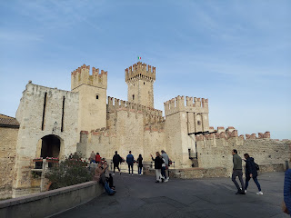

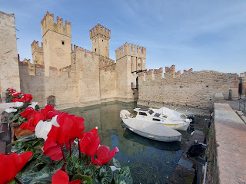

Scaligero Castle was built in the 13th century. Wowza. Shockingly, it was only $6/each to get inside for a tour.

(English explanation is on the lower right in the photo below)

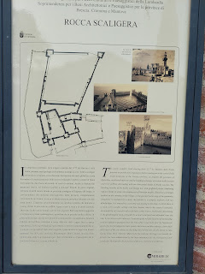

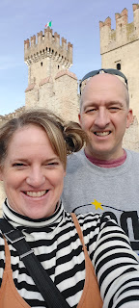

Ya gotta have lots of stairs if you're going to live in a castle. There's just no other way.

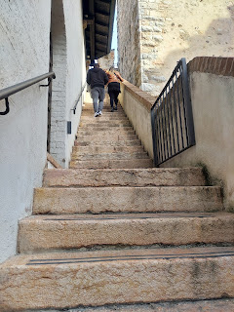

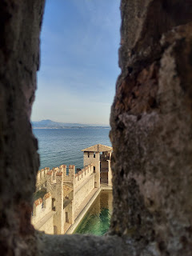

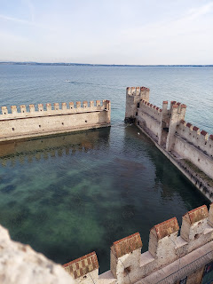

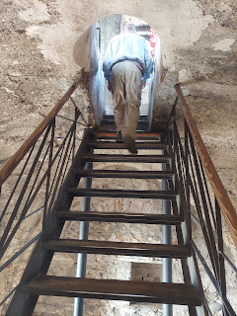

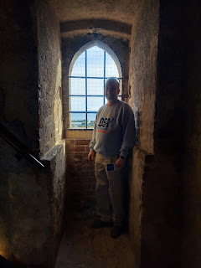

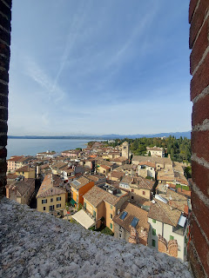

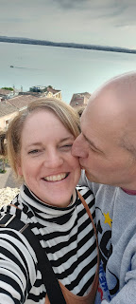

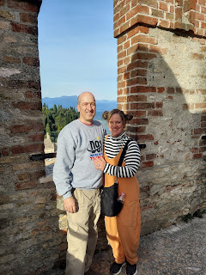

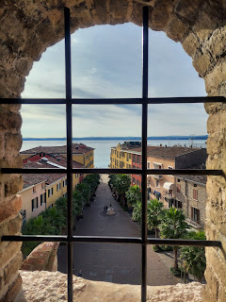

So magical . . .

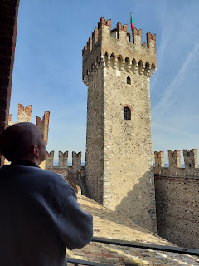

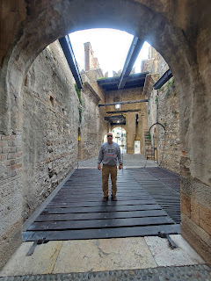

There was a random black cat in one of the castle courtyards.

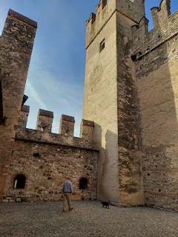

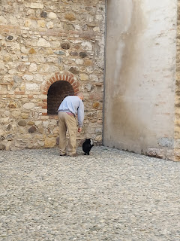

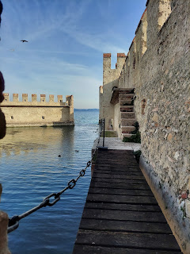

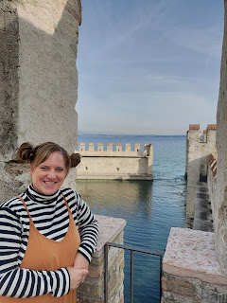

Video looking out over the water from the castle: (36 seconds)

https://photos.app.goo.gl/zXRbCYvWBXNKpD3W7

To find out more about Scaliger Castle, you can click here:

https://lakegardatravel.net/scaliger-castle-sirmione-lake-garda/

Near the exit of the castle are a couple of ancient Pirogues - boats that were recovered and then dated from the medieval age. I'm always in awe when something is preserved from THAT long ago. Holy moly.

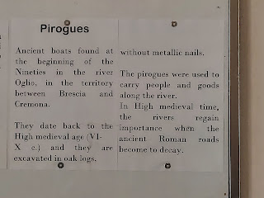

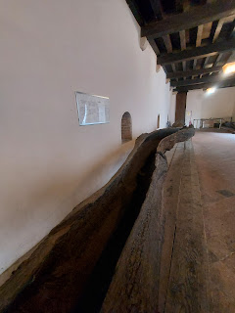

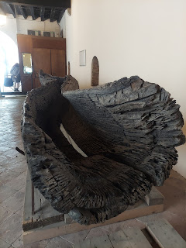

The castle sits adjacent to a LOT of shops and restaurants. For lunch, we decided to get some gelato. (Because it has milk and milk is healthy.)

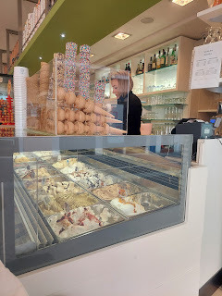

From the castle, we walked out toward the northernmost tip of Sirmione - to a beach called Jamaica Beach. I'm not sure why it's called that, but the pictures online looked intriguing so we made our way there. It was only about 10 minutes on foot from the castle, and there were certainly plenty of interesting things to see along the way.

Private artisan gardens . . .

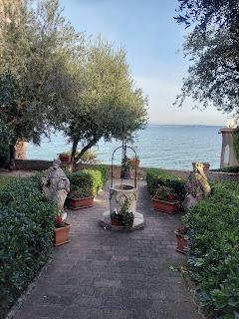

A sign that says KISS . . . PLEASE - -

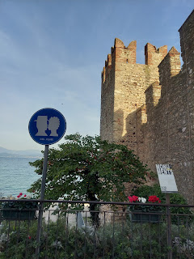

When in Rome . . .

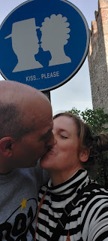

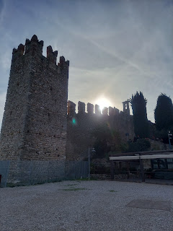

The beach was sprawling and beautiful, covered in white limestone rocks everywhere.

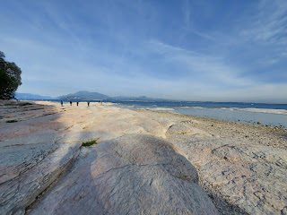

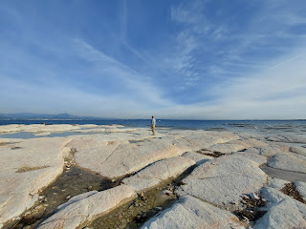

Scott - (below) was being cheeky with all sorts of poses while I was trying to take his picture. What a guy!

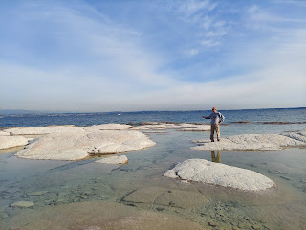

Video of the 360 degree views: (26 seconds)

https://photos.app.goo.gl/hqZxqqz3qjQDnznX7

We were very curious about these lower rocks near the turning point of the beach. They definitely looked manmade. But why? There were also several metal anchors wedged in along the height of the rocky cliffs. But why?

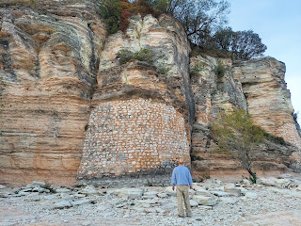

Since we didn't have any answers, we just kept on walking. We walked around the northern tip, and started down the other side.

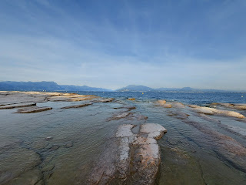

At one point, we just happened to look BACK and HOLY COW - look what we missed earlier and didn't even notice . . .

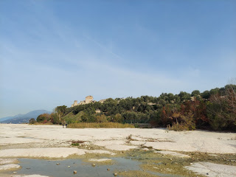

I had read about some ancient Roman ruins at Sirmione but didn't take note of where they were. Well, we found them, ha ha. Sort of. We couldn't get up there from where we were, and had to move along with our day, so we decided to skip that for now. The area is called: Grottoes of Catullus. The ancient villa is dated back to the end of the 1st century BC and into the 1st century AD.

Scott called his brother Gordon as we walked along, and enjoyed showing him everything that we were seeing.

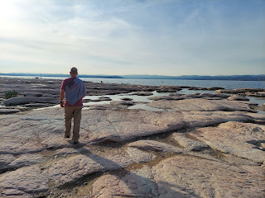

Eventually we ended up back in the shopping district where we could see the Castle again.

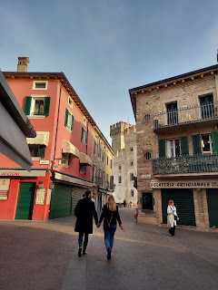

I liked this sign very much. We think similarly. :)

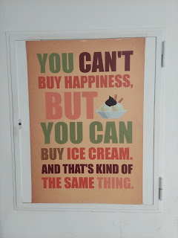

And at the very last second before we left the castle area, we saw this VERY OLD church - named Ave Maria. The official name of it is Santa Maria Maggiore and it's dated back to the 15th century.

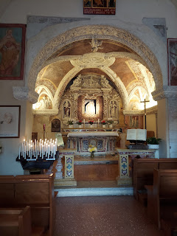

I didn't know how old it was at the time, but I knew it had to be OLD. I just took a couple of quick pictures inside because the time had already expired on our parking spot for the car, so Scott was tapping his toe . . . (not really, but it felt like he was!)

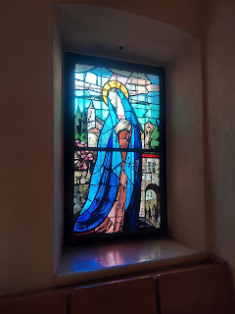

This GOLD Rolls Royce was sitting out in the parking lot. It had some advertising on the side for a local REALTOR!! Go figure!! ha ha

There will always be something in this world to amaze me.

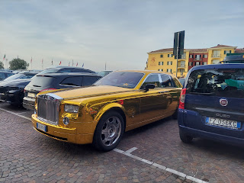

From Sirmione, we drove east to Verona for the rest of the day. Our friends, CB and Andrea, gave us some gift certificates to Aquardens, a thermal spa and sauna experience, so we decided to cash that in. I'm not sure how it's pronounced, but we tend to add an extra couple of letters to call it AquaGardens.

It was definitely the fanciest place I've ever been to and oh-so-relaxing.

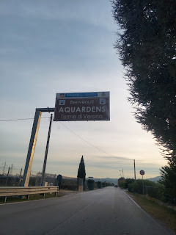

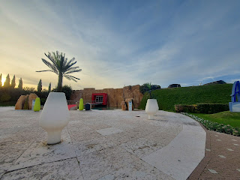

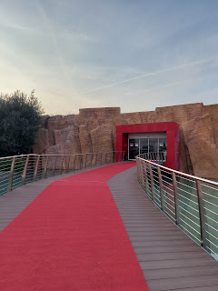

As you enter, they give you a waterproof silicone wristwatch to wear. It is color-coded for the hour that you arrived. Everything that you do from that point on, you do with the watch. Need to rent a towel? Tap the watch on the screen at the towel counter to add it to your tab. Need a drink or some food? Tap the watch. Need to get in and out of your locker? Tap the watch on the locker button.

At the end of your visit, you pay before you exit and turn in the watch. What a genius idea!

There are SEVERAL different thermal pools to choose from, some are indoors, some are outdoors. You can freely go from one to the next, and occasionally you do have to get out and walk to the next area.

This is the only photo that I took. My phone is not waterproof like so many i-Phones are, so I didn't want to carry it around with me.  But you can look on their website to learn more about what they offer.

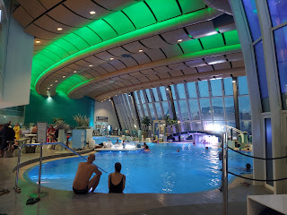

This is the link to their website. I hope it works for you because Google automatically translates everything to English for me . . .

https://www-aquardens-it.translate.goog/it?_x_tr_sl=it&_x_tr_tl=en&_x_tr_hl=en&_x_tr_pto=sc

There are caves and waterfalls with glowing lights of red, blue, or green to make it even more interesting. Several pools had jets that came on automatially every 10 minutes or so and ran for about 10 minutes.  You can swim right up to a bar and get a drink or a snack. We didn't do that. We just swam for hours.

Our favorite area to hang out in was the outdoor river. It had a lively current and went around in a large oval shape. We went around and around and around. Most pools have a temperature of 35-37 degrees Celsius. It was quieter outside, and eventually we could watch the sunset and see the stars begin to pop out above us. It was just lovely.

All too soon it was time to get dressed and leave. How sad. This is definitely a place we would love to bring our children and granchildren (and other friends and family members) when they come to visit. Hurry up you guys and get over here!!!

When we got back to our AirBnB, we took the same short walk up toward the castle behind our apartment because there was a kebab restaurant next door and that's Scott's favorite fast food. Yumm!

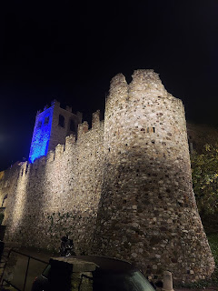

Saturday:

After a lazy morning and getting checked out of our lodging, we started driving toward Malcesine (pronounced: Mal-cheh-SEE-nay) to ride the cable car up to the the top of Monte Baldo. But a few minutes into our drive, I saw online that the cable car was closed for some reason. I called and listened to a message in Italian AND in English that said yes, it was closed for some programmed maintenance.

After some quick research, we decided to try our hand at driving up as far as we could go on our own. The entire drive was spectacular. Every single inch.

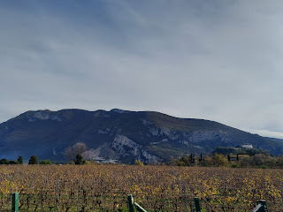

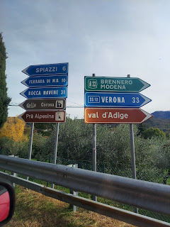

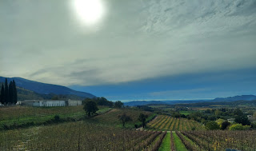

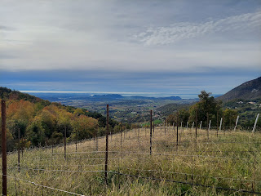

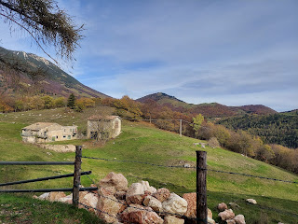

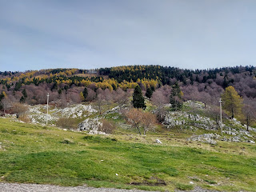

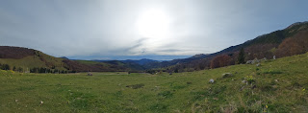

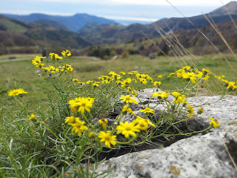

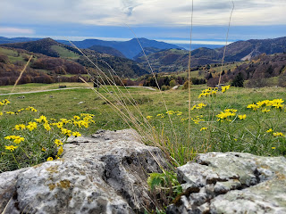

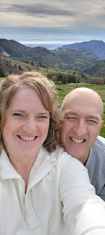

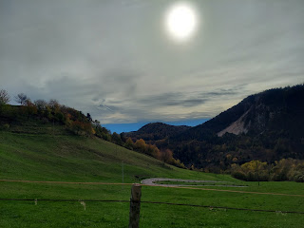

There was even an alpine cemetery with perfectly lined rows of white headstones.

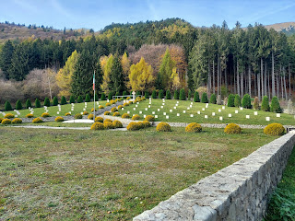

There were times that the road was so steep that Scott just stayed in 2nd gear the whole time.

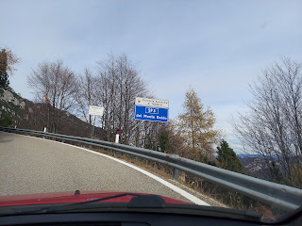

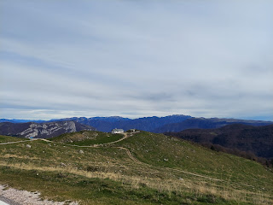

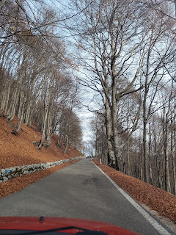

We stopped briefly at this roadside marker to get our bearings on all the mountains around us.

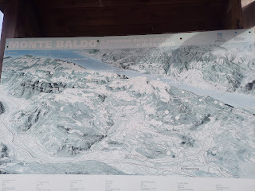

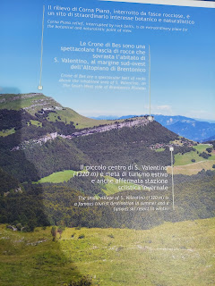

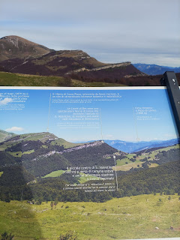

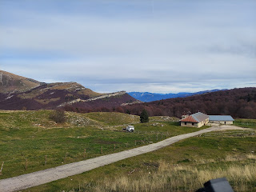

And then we continued to go up and up some more.

Video #1 going up to Monte Baldo: (38 seconds)

https://photos.app.goo.gl/hnXqn29kgTJLPjQp9

Video #2 going up to Monte Baldo: (20 seconds)

https://photos.app.goo.gl/jCq9PGQz2MHkHjHj7

FINALLY, we made it to a safe area to park before the pavement turned to gravel. We could see a little bit of Lake Garda through all the trees . . .

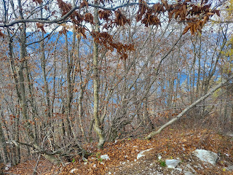

I scurried off on a faux trail that didn't lead very far. The reason? I needed to go potty.

Yep. I went potty in a little patch of forest on top of Monte Baldo. Tee hee. (Thankfully we had a roll of TP in our car.)

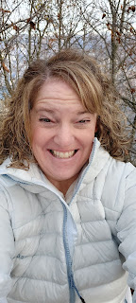

Then we began our trek up the rest of the way to the top.

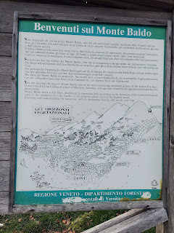

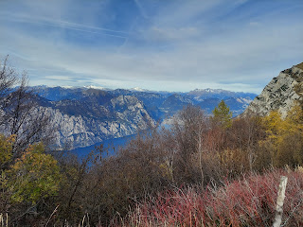

Around the same time that we began walking up the gravel road, we met up with a couple of Germans. We ended up staying together for the entire 2.5 miles round trip. They were super nice and we learned a lot about them.

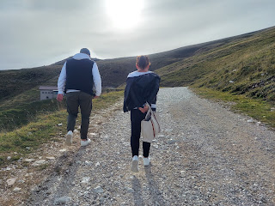

Their names are Johannes (John) and Lena. They are from a small town near Hamburg. He is a purchaser for a trailer company and, prior to Covid, he traveled to China, Poland, Ukraine, and Russia quite often. Not so much traveling now, especially with the war going on as well.

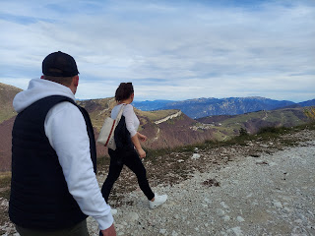

They have 3 children, ranging in age from 14 down to 3, who were in the care of Lena's parents so that the two of them could go on a trip by themselves. They come down to Lake Garda every single year. I learned more about their history, too. His ancestors were from the Hamburg area, but in the late 1800's they moved away to Kazakhstan for a better life. They only just returned to the Hamburg area in 1992. They showed us pictures of their house and it is beautiful!

We had fun exchanging information and stories about our towns and neighborhoods as we walked along. They spoke very good English. Well, Johannes did, but Lena struggled a bit more. She understands more than she can speak. I know the feeling . . .

We passed an abandoned dairy partway up. I think it was past season for the cows to be up that high on the mountain.

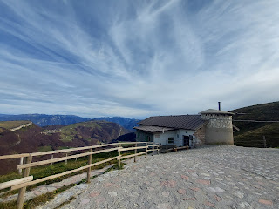

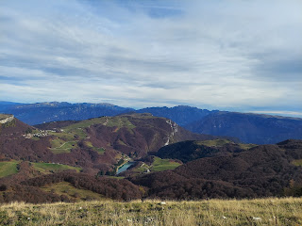

The elevation at the top of Monte Baldo is 1790 meters. (5872 feet)

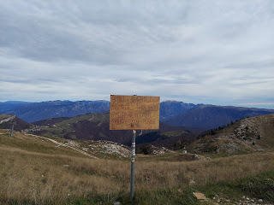

This is the cable car station where we would have gotten off if it had been working. It's also a small ski resort when the snow eventually comes.

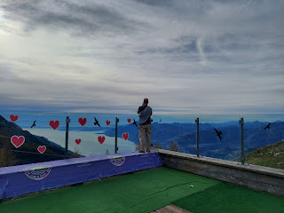

Lake Garda is quite large . . .

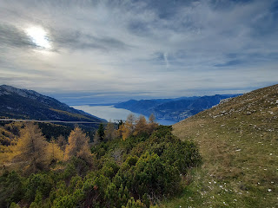

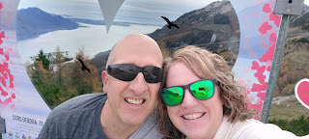

Even though we were winded, we found another trail off to the side, and decided to go see if we could see the northern end of the lake any better.

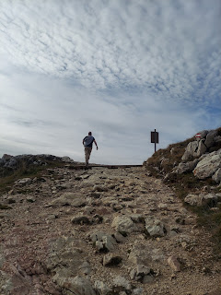

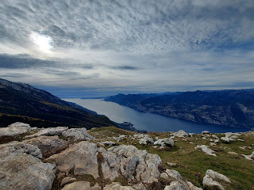

We shared this next photo with some family members to see if they could find Scott in this photo. Good luck!

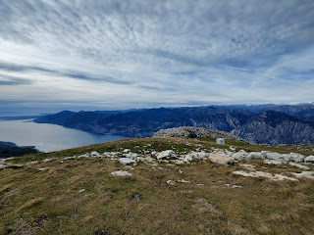

He called his brother, Gordon, again to share the magnificent views. You can see the snow-capped Swiss Alps off in the distance.

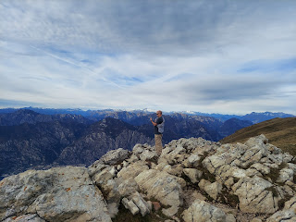

Our new friends were gracious enough to take some photos of us, and we did the same for them.

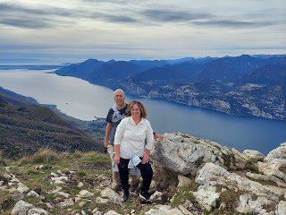

Something we noted as a group is how QUIET everything was. Not just from where we stood, but even the lake below. The busy summer season is long gone now. No boats, no ferries, no planes in the sky. Just beautiful silence. It was hard to turn around and leave that peaceful scene.

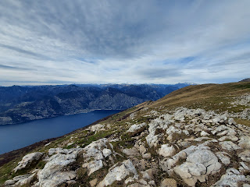

Short video before we left our perch: (10 seconds)

https://photos.app.goo.gl/aYpXJNApA9rTGqzQ8

You can see the snowy alps in the distance on our way down the road. I'm not sure where the Swiss Alps become the Austrian Alps, but I just know that we could see several layers of mountain ranges.

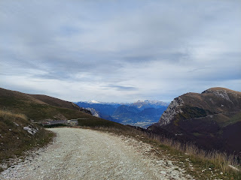

We took a slightly different route coming down from Monte Baldo, since we were headed back to Vicenza now. We both really enjoyed seeing even more new things on the way. Like this cute little chalet, tucked up against a hillside and cliff out in the middle of nowhere.

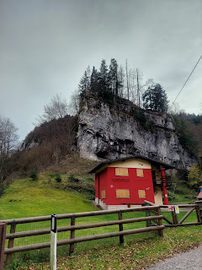

Both going up and coming down, we encountered SEVERAL hairpin turns. Sometimes Scott could get out of 2nd gear, but not very often, ha ha. These photos do NOT portray how truly exquisite the mountains were around us. I could have taken hundreds more photos and you would still not be able to put them into proper perspective. You'll just have to come over and we will show you in person. That is the ONLY WAY.

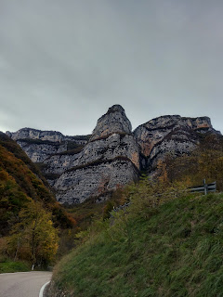

Video of part of our drive down the mountain: (34 seconds)

https://photos.app.goo.gl/iCoCiCmaVwWoKjG69

Below you can see one of the hairpin turns.

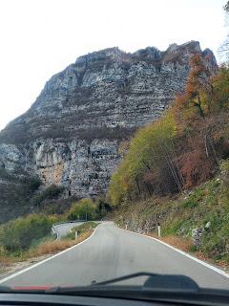

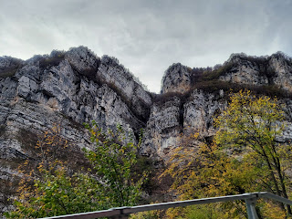

At the bottom of the mountains and just before we connected with the freeway, we came into this super cute town of Avio, where I saw a giant castle tucked into the cliffs.

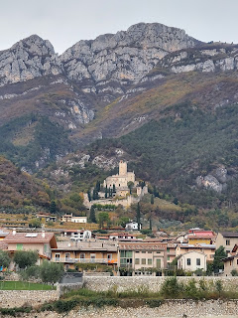

I found some interesting information about the castle as we drove. It was built prior to 1053!!! DANG. I would LOVE to tour that ginormous castle sometime soon. It's less than an hour from our house.

You can find out more for yourself at this Wikipedia link:

https://en.m.wikipedia.org/wiki/Castle_of_Avio

What an amazing weekend. We said to ourselves many times, "This is UNBELIEVABLE!" And it truly was. I am so grateful for this beautiful world we live in. For mountains, lakes, and streams. For ancient civilizations that leave behind clues to their existence. For quiet moments and peaceful vistas. And for someone to share it all with.

A Little Bit from Grandbabies . . .

Jack and his family took a road trip to Philadelphia for the weekend. He fell asleep in his carseat before they even left home . . . what a cutie.

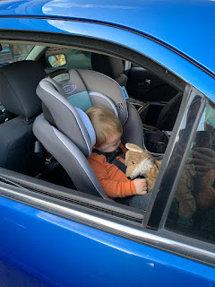

Jacob and Jack found a little den to hang out in. I love this picture so much!!

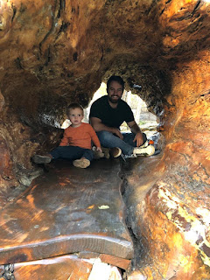

They also took Jack to see the Philadelphia Temple. I love how he's always holding his little Wolfie. And I love how he's peeking over at the temple with wonderment and curiosity. Someday he'll be old enough to go inside.

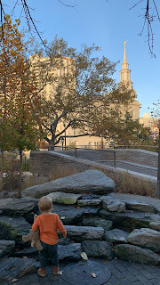

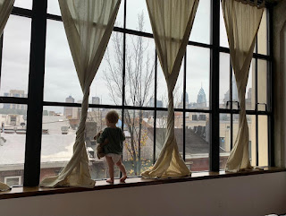

Amber sent us this photo of Gwen putting together a puzzle at school. She is (along with her sister) such a whiz at puzzles! She has endless concentration and patience for puzzles at such a young age.

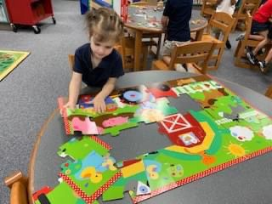

Scott also found this old picture of Gwen and we laughed and laughed over it. LOL

She looks like she's got some sort of maniacal plan in place to take over the world or something . . . moo-ha-ha-ha-haaa

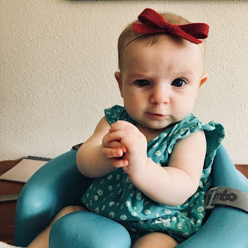

And then here's a super cute video of Gwen on the way to school this week. She loves the song that came on the radio. (20 seconds)

*You'll need to turn the sound up a bit to hear the song in the background. I think Gwen is tapping to the beat with her carseat straps, ha ha.

https://photos.app.goo.gl/1hAzj2aUL7DyL7V98